**CODING CONVENTIONS**

**1. Code layout:**

* Indented code according to nesting level

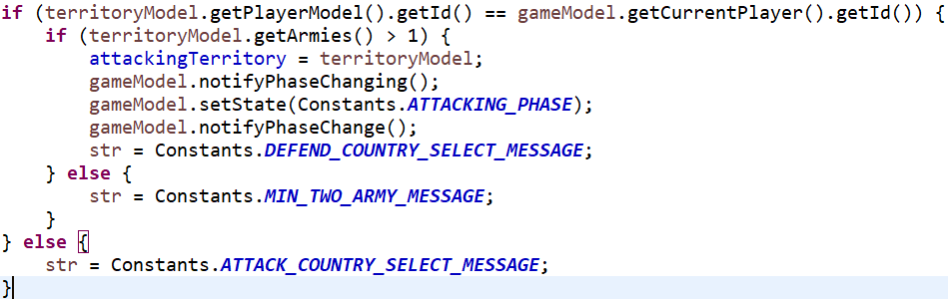

* Body of the function is indented with its function header.

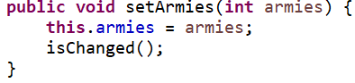

* Format statements, appending open curly brace to the statement that precedes it.

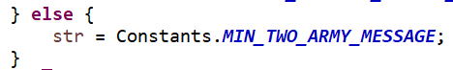

* Blank lines, between methods definitions, variable declaration, class declaration, major sections of a long and complicated code.

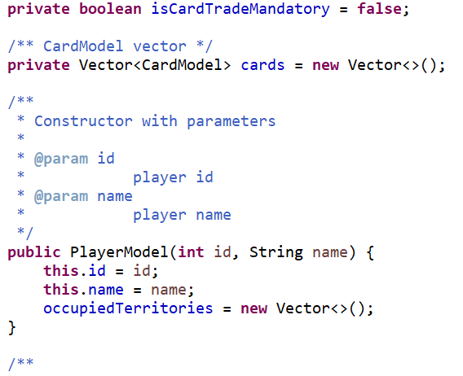

**2. Naming conventions:**

* Constants are named with uppercase letters and each word is separated by underscore.

public static final int NEW_GAME = 1;

* Local variables and data members are descriptive names and if it contain multiple words each word is separated by capital letter at the beginning of each word.

GamePhase gamePhase = null;

* Class names should start with capital letter and it should be simple and short, if name contains multiple words each word is separated by capital letter at the beginning of each word.

public class PlayerModel{}

* Method names should start with lower case letter and use upper case letters to separate words.

public PlayerModel(int id, String name) {}

**3. Commenting conventions:**

* Each class declaration is proceeded by a comment (that used to generate java doc) explaining what the purpose of the class.

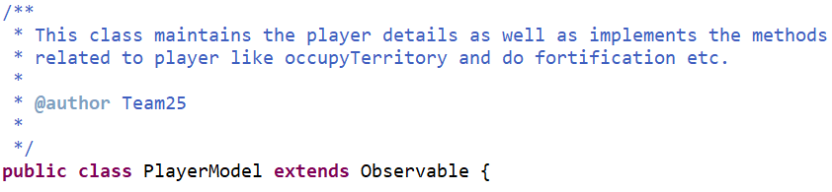

* Each method should have comments explaining what it does, as well as the purpose of its parameters.

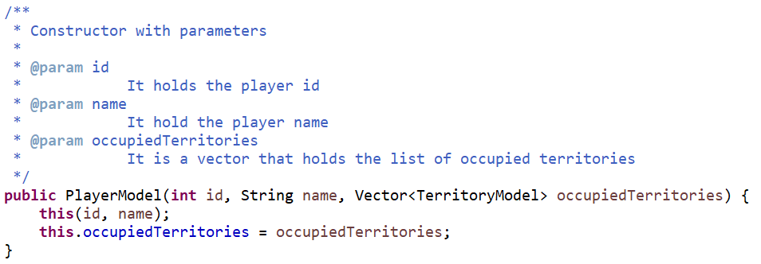

* All class data members, should be appended with a comment describing its role.

